**Networking Concepts:**

**1.HUB :** It is a networking device.It helps to connect several devices to a single network.

* A hub is a multi-port repeater. A hub connects multiple wires coming from different branches, for example, the connector in star topology which connects different stations.

Example: USB

**2. Repeater :** It is a device that amplifies or regenerates the signals to that the signals can reachout to the device. repeater is defined as a device that is used to amplify and retransmit the signals of incoming packets to the other side of the segments.

* repeater is an electronic device that receives a signal and retransmits it. Repeaters are used to extend transmissions so that the signal can cover longer distances or be received on the other side of an obstruction.

**3. SWITCH**:

* It is an advanced device which can selectively forward the data packets
* It is a equipment that allows two or more devices such as computers to communicate each other.

**4. Router:**  
o   A router is a networking device that forwards data packets between computer networks.  
o   It operates at the network layer of the OSI model and uses routing tables to determine the best path for forwarding packets.  
o   Routers are essential for connecting multiple networks together, such as connecting a home network to the internet.

**5.Bridge:**-A bridge is a networking device that connects multiple network segments together and forwards traffic between them.   
-It operates at the data link layer of the OSI model and uses MAC addresses to determine which segment to forward a packet to.   
-Bridges are typically used to divide large networks into smaller, more manageable segments or to connect different types of network technologies.

**6. Gateway:**   
-A gateway is a networking device that serves as an entry and exit point for data entering or leaving a network.   
-It can perform protocol translation, data formatting, or other functions necessary to facilitate communication between different networks or between a network and external systems, such as the internet.   
-Gateways often combine the functions of routers, bridges, and other devices to provide comprehensive connectivity services.

It is simply an Entry or Exit point for data entering & leaving the network.

**NETWORK TOPOLOGIES :**

Network topology refers to how various nodes, devices, and connections on your network are physically or logically arranged in relation to each other.

1. **Point to point Topology:**

* Point-to-point networks contain exactly two hosts such as computers, switches or routers, servers connected back to back using a single piece of cable.
* Often, the receiving end of one host is connected to the sending end of the other and vice-versa.
* If the hosts are connected point-to-point logically, then they may have multiple intermediate devices. But the end hosts are unaware of the underlying network and see each other as if they are connected directly.

1. **Bus Topology :**

* In case of Bus topology, all devices share a single communication line or cable.
* Bus topology may have problems while multiple hosts sending data at the same time.
* Therefore, Bus topology either uses CSMA/CD technology or recognizes one host as Bus Master to solve the issue.
* It is one of the simple forms of networking where a failure of a device does not affect the other devices. But failure of the shared communication line can make all other devices stop functioning.
* Both ends of the shared channel have a line terminator. The data is sent in only one direction and as soon as it reaches the extreme end, the terminator removes the data from the line.

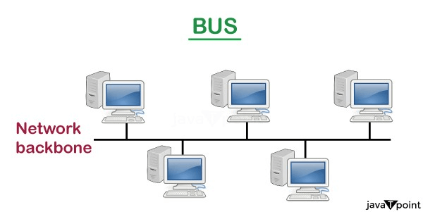

**CSMA:** It is a media access control used to control the data flow so that data integrity is maintained, i.e., the packets do not get lost. There are two alternative ways of handling the problems that occur when two nodes send the messages simultaneously.

* **CSMA CD:** CSMA CD (**Collision detection**) is an access method used to detect the collision. Once the collision is detected, the sender will stop transmitting the data. Therefore, it works on "**recovery after the collision**".
* **CSMA CA:** **CSMA CA (Collision Avoidance)** is an access method used to avoid the collision by checking whether the transmission media is busy or not. If busy, then the sender waits until the media becomes idle. This technique effectively reduces the possibility of the collision. It does not work on "recovery after the collision".

**3.RING TOPOLOGY:**

* In ring topology, each host machine connects to exactly two other machines, creating a circular network structure.
* When one host tries to communicate or send message to a host which is not adjacent to it, the data travels through all intermediate hosts.
* To connect one more host in the existing structure, the administrator may need only one more extra cable.

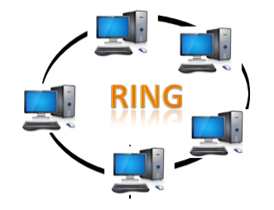

* Failure of any host results in failure of the whole ring. Thus, every connection in the ring is a point of failure. There are methods which employ one more backup ring.
* The most common access method of the ring topology is **token passing**.
* **Token passing:** It is a network access method in which token is passed from one node to another node.
* **Token:** It is a frame that circulates around the network.

**4. Star Topology:**

* All hosts in Star topology are connected to a central device, known as hub device, using a point-topoint connection.
* That is, there exists a point to point connection between hosts and hub. The hub device can be any of the following:

ν Layer-1 device such as hub or repeater

ν Layer-2 device such as switch or bridge

ν Layer-3 device such as router or gateway.

* As in Bus topology, the hub acts as a single point of failure.
* If the hub fails, connectivity of all hosts to all other hosts fails.

Every communication between hosts takes place through only the hub.

* Star topology is not expensive as to connect one more host, only one cable is required and configuration is simple.
* The central computer is known as a **server**, and the peripheral devices attached to the server are known as **clients**.
* Coaxial cable or RJ-45 cables are used to connect the computers.

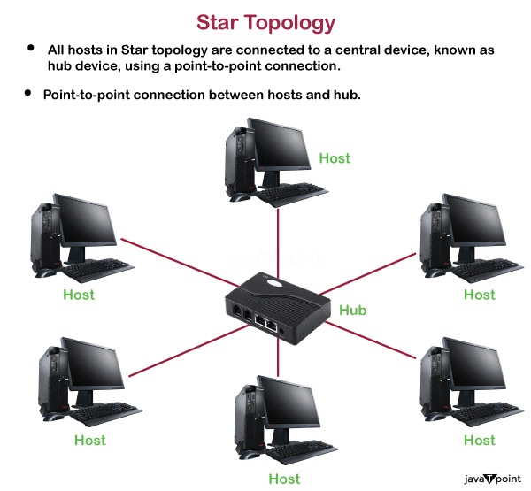

### Advantages of Star topology

1.Efficient Trouble shooting

2.Easily expandable

3.Limited failure

4.High data speeds

**5.Mesh Topology** :

* In this type of topology, a host is connected to one or multiple hosts.
* This topology has hosts in pointto-point connection with every other host or may also have hosts which are in point-to-point connection to few hosts only.
* Hosts in Mesh topology also work as relays for other hosts which do not have direct point-to-point links. Mesh technology comes into two types:
* ν Full Mesh: All hosts have a point-to-point connection to every other host in the network. Thus for every new host n(n-1)/2 connections are required. It provides the most reliable network structure among all network topologies.
* ν Partially Mesh: Not all hosts have point-to-point connection to every other host. Hosts connect to each other in some arbitrary fashion. This topology exists where we need to provide reliability to some hosts out of all.

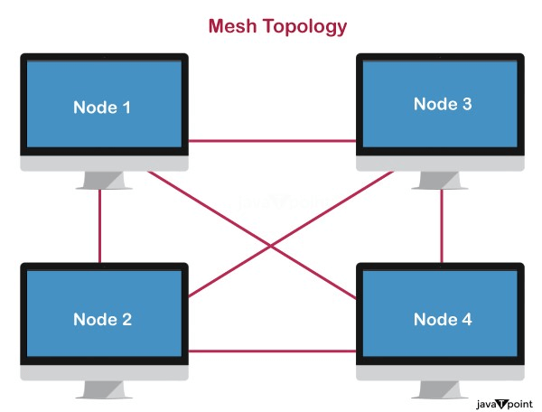

* Mesh technology is an arrangement of the network in which computers are interconnected with each other through various redundant connections.
* There are multiple paths from one computer to another computer.
* It does not contain the switch, hub or any central computer which acts as a central point of communication.

**6.Tree Topology** :

Also known as Hierarchical Topology, this is the most common form of network topology in use presently. This topology imitates as extended Star topology and inherits properties of bus topology.

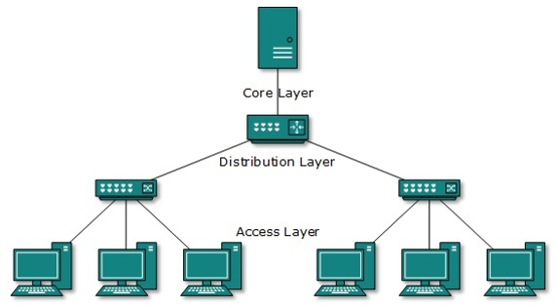

* This topology divides the network in to multiple levels/layers of the network.
* Mainly in LANs, a network is bifurcated into three types of network devices.
* The lowermost is an access-layer where computers are attached. The middle layer is known as the distribution layer, which works as a mediator between upper layer and lower layer.
* The highest layer is known as the core layer, and is the central point of the network, i.e. root of the tree from which all nodes fork.
* All neighboring hosts have point-to-point connection between them. Similar to the Bus topology, if the root goes down, then the entire network suffers even. Though it is not the single point of failure. Every connection serves as a point of failure, failing which divides the network into unreachable segments.

**7. Daisy Chain :**

* This topology connects all the hosts in a linear fashion.
* Similar to Ring topology, all hosts are connected to two hosts only, except the end hosts. Means, if the end hosts in daisy chain are connected then it represents Ring topology.
* Each link in daisy chain topology represents single point of failure. Every link failure splits the network into two segments. Every intermediate host works as relay for its immediate hosts.

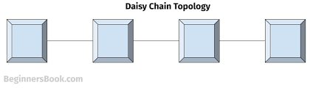

**8.Hybrid** **Topology :**

* A network structure whose design contains more than one topology is said to be hybrid topology. Hybrid topology inherits merits and demerits of all the incorporating topologies.

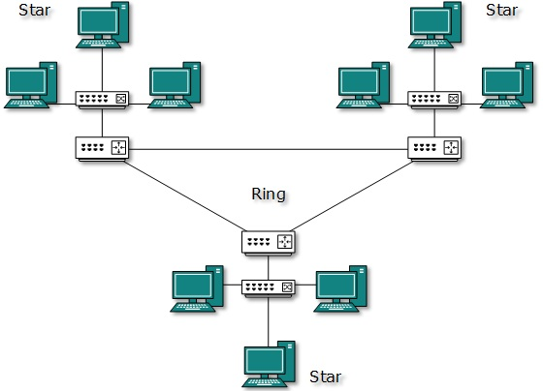

* The above picture represents an arbitrarily hybrid topology. The combining topologies may contain attributes of Star, Ring, Bus, and Daisy-chain topologies.
* Most WANs are connected by means of Dual-Ring topology and networks connected to them are mostly Star topology networks.
* Internet is the best example of largest Hybrid topology.